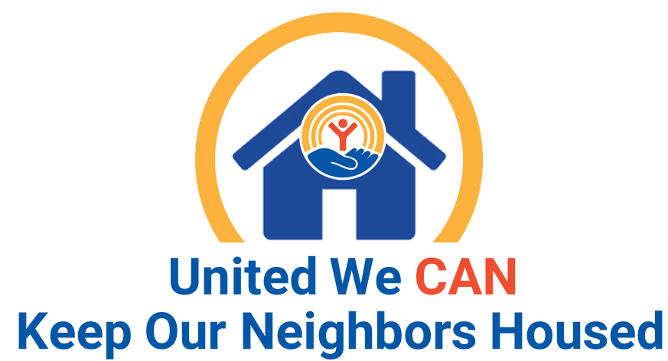
UWVP Selected to Receive Continuation Funding to Lead the Peninsula Eviction Reduction Pilot (PERP)

Earlier this year, United Way of the Virginia Peninsula was selected to receive $850,000 in continuation funding to provide eviction prevention and diversion services, as well as a court navigator program to the Virginia Peninsula community. This funding will provide much needed housing stability to our neighbors in need, helping at-risk households avoid going further into the cycle of poverty and get onto the pathway to self sufficiency. This funding also allows UWVP and various organizations on the Peninsula to work together to address gaps in resources for households facing eviction, and work towards creating community-wide solutions to better serve individuals and families on the verge of experiencing homelessness.

﻿If you or anyone you know is facing a poverty related crises and resides on the Virginia Peninsula, call our Community Assistance Network (CAN) at 757-229-2222 to be connected with the services and programs of more than 150 network partners helping to keep our neighbors housed, healthy, and thriving. For more information on CAN, visit www.uwvp.org/unitedwecan

