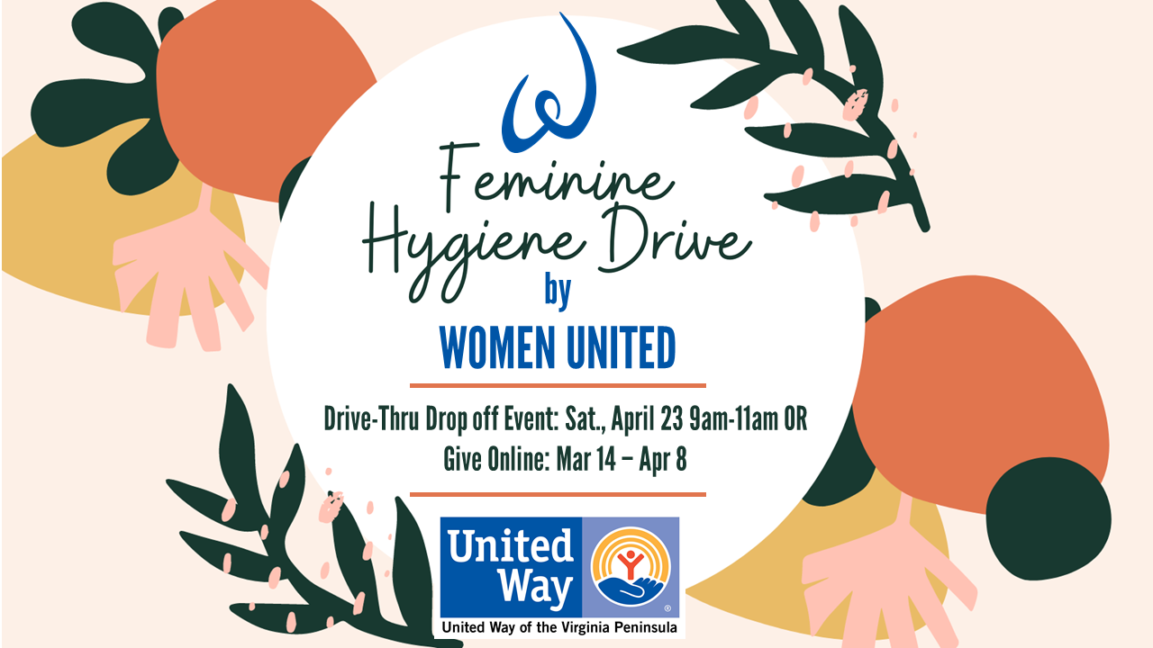
SIGN UP AVAILABLE NOW! Saturday, April 23 between 9am-11am is Women United's 2022 Feminine Hygiene Drive

Last year, Women United members, volunteers, and supporters collected over 300 feminine hygiene products, resulting in ~$15,000 of goods that were distributed to our nonprofit partners who serve women of all ages experiencing poverty. This year, our goal is to collect 500 items!

﻿GET INVOLVED:

1) Join us for a drive-thru drop off at the UWVP office on Saturday, April 23 between 9am-11am.
Click HERE to RSVP

2) Give Online - Now through April 8, products will be available to purchase for direct delivery.
Click HERE to give online.

3) Collect Items! Contact womenunited@uwvp.org to arrange a time for a UWVP representative to drop off a collection bin(s).

