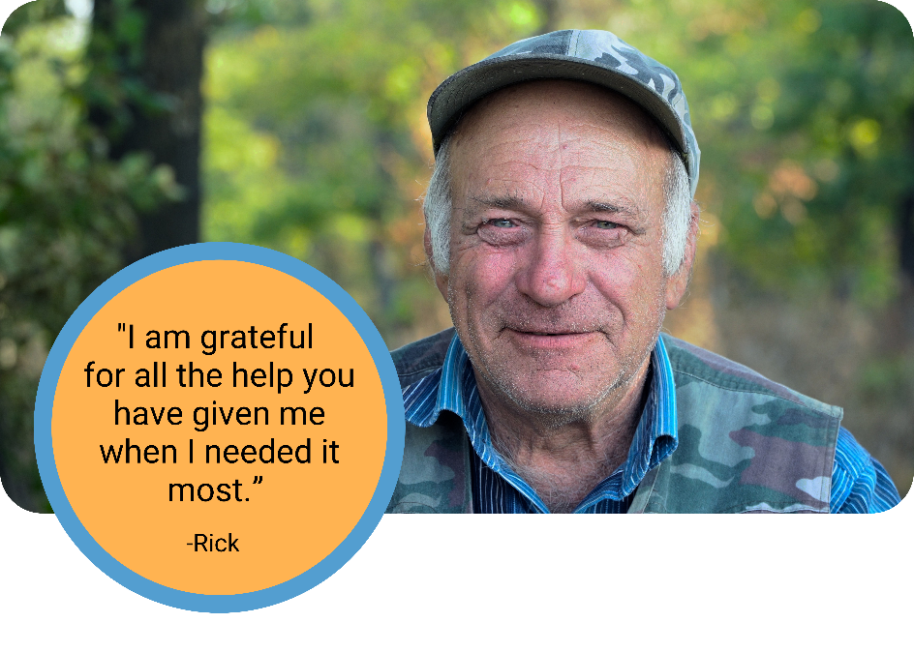

Subject: SUCCESS STORY SEPTEMBER
Rick has a full-time job in Hampton, but got laid off during COVID-19. Because of an underlying heart condition and Diabetes, Rick struggled to find work during the pandemic. Through the United Way Community Assistance Network (CAN), Rick was referred to THRIVE, Inc. and St. Marks United Methodist Church for access to food pantries, and to Our Lady of Mt. Carmel for assistance with his Insulin co-pay. Finally, a United Way CAN advocate referred Rick to the state Rent Relief Program for rental assistance, and helped him apply a credit to his Dominion power bill. When an individual like Rick faces a hardship, it usually takes the expertise of multiple agencies to find the help they need. This is where United Way comes in - to bridge those resources and find solutions to solve the entire issue.
﻿
If you or anyone you know is facing a poverty related crisis, call United Way's CAN at 757-229-2222. For more information on CAN, visit www.uwvp.org/unitedwecan

