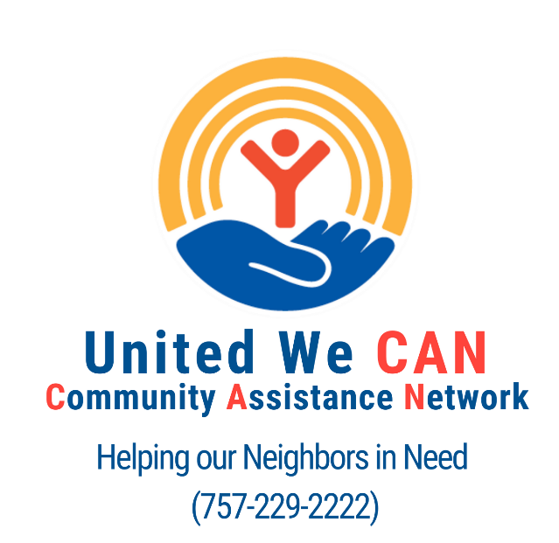

Subject: UNITED WE CAN
If you or anyone you know if facing a poverty related crises and resides on the Virginia Peninsula, call United Way's CAN at 757-229-2222. Until recently, United Way of the Virginia Peninsula maintained two separate information and referral services – the Community Resource Center (which primarily served the upper Peninsula) and First Call (which primarily served the lower Peninsula). As of July 1st, United Way has one, robust network of community partners working together to keep our neighbors housed, healthy, and thriving: United We CAN (Community Assistance Network). The CAN consists of diverse organizations providing the critical programs and services our at-risk neighbors need to overcome the cycle of poverty.
For more information, visit www.uwvp.org/unitedwecan.

