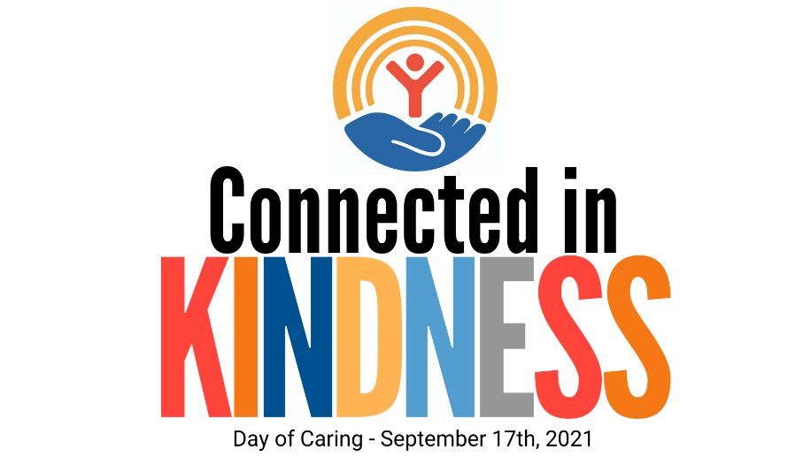

Subject: DAY OF CARING 2021
Join United Way of the Virginia Peninsula for Day of Caring 2021 on Friday, September 17th! United Way's Day of Caring is the Peninsula largest day of the year for volunteering, brining the community together to create a positive impact on the nonprofits and human service providers that help those most in need. Thousand of individuals and companies are connected to volunteer opportunities, giving those who live and work on the Peninsula a deeper awareness of local needs.

Get involved by signing up as an individual or as a team by registering here between August 2 - August 20, 2021.

