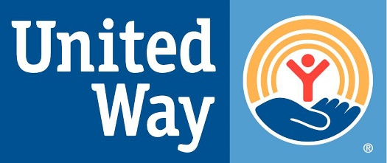
United Way of the Virginia Peninsula
Two City Center, 11820 Fountain Way #206
Newport News, VA 23606 USA

Media Contact:
Steven S. Kast, President & CEO
United Way of the Virginia Peninsula
757.873.9328
skast@uwvp.org

UNITED WAY OF THE VIRGINIA PENINSULA RECEIVES $1,050,000 FOR RENT AND MORTGAGE RELIEF
NEWPORT NEWS, VA – March 8th, 2021– United Way of the Virginia Peninsula (UWVP) received $1,050,000 for rent and mortgage relief through the 2021 Virginia Eviction Reduction Pilot (VERP) program. This funding will help provide eviction prevention services to the Virginia Peninsula communities including: Gloucester County, City of Hampton, James City County, Mathews County, City of Newport News, City of Poquoson, City of Williamsburg, and York County.
As an organization dedicated to the wellbeing of our community, UWVP quickly formed unique partnerships to ensure those affected by COVID-19 could receive the support they needed. Programs to help prevent evictions for families directly impacted by COVID-19 included the Rent & Mortgage Relief Program (RMRP) and the Hampton Eviction Prevention Program (HEPP). The VERP grant funding will enhance current programs, services, and referral systems, creating a network of housing solutions and other necessities for individuals facing eviction on the Virginia Peninsula. Funds will be used to cover rent, utilities, legal expenses, child care, and other necessities to build capacity and support prevention programs already in place to address the underlying causes of evictions for long term eviction prevention.
“Unfortunately, the affordable housing crisis is not new, it has only been amplified as we continue to experience the repercussions from COVID-19,” states United Way of the Virginia Peninsula President and CEO, Steve Kast. “This funding will allow our community to continue the necessary work to help our neighbors in need and help improve our community’s overall resilience and ability to deliver eviction prevention services now and into the future.”
Using a collective impact model, UWVP and partners will serve as a safety-net for individuals and families experiencing housing instability and who are at-risk of being evicted. These prevention services include both short term financial assistance and long term case management assistance to ensure households have the tools to reach stability moving forward.
###
About United Way of the Virginia Peninsula
United Way believes we can achieve more together than any of us could do on our own. That's why our board is committed to our mission of uniting people, organizations, and resources to improve lives in the Virginia Peninsula. By fostering community partnerships, we can champion shared goals and align resources to deliver innovative, holistic solutions to our community's most pressing issues, with a focus on coming together to break the cycle of poverty.
Whether United Way is funding others to provide services, delivering services or coordinating collaborative programs, we are working together to create a path to stability and self-sufficiency. By focusing on the building blocks of health, education, and financial stability to create “Pathways Out of Poverty”, we don't just change lives - we change what's possible. Learn more at www.uwvp.org.

